**8.13 Area and Perimeter of Triangles on the Coordinate Plane Classwork**

1. Graph the following points: A(0,4) B(-6,0) C(8,0)

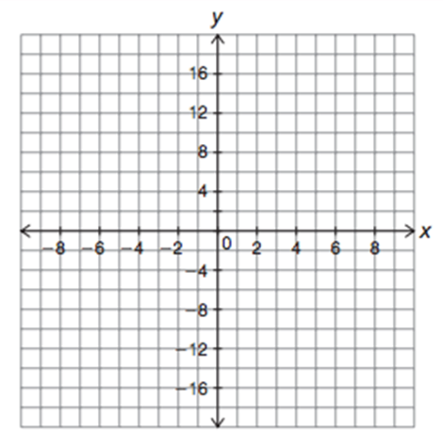

Calculate the perimeter of triangle ABC.

Calculate the area of triangle ABC.

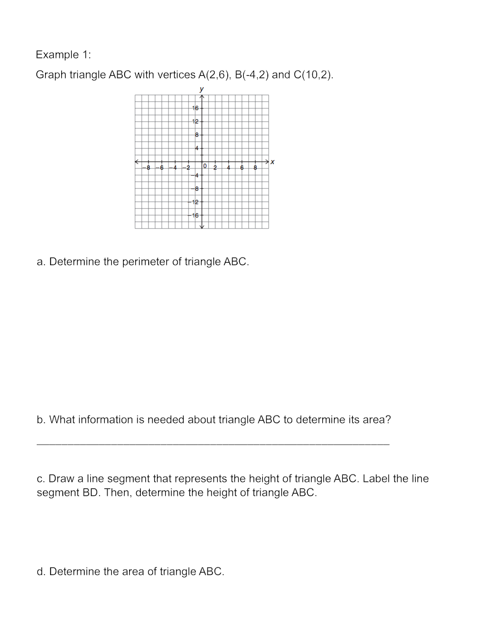2.

**8.13 Area and Perimeter of Triangles on the Coordinate Plane HW**  
*Determine the area and perimeter of the following triangles*

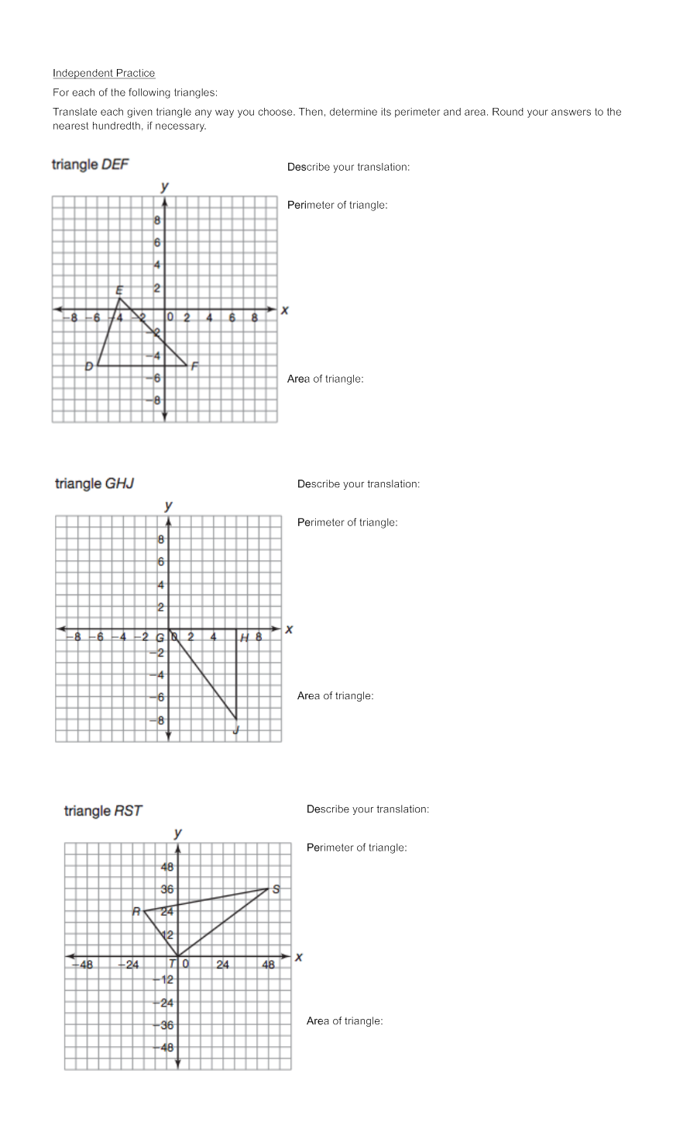





8.13: Perimeter and Area of Triangles in the Cartesian Plane Exit Ticket

1. Given the triangle below with vertices $A (-2, 3)$, $B (4, 4)$, and $C (-1, -2).$

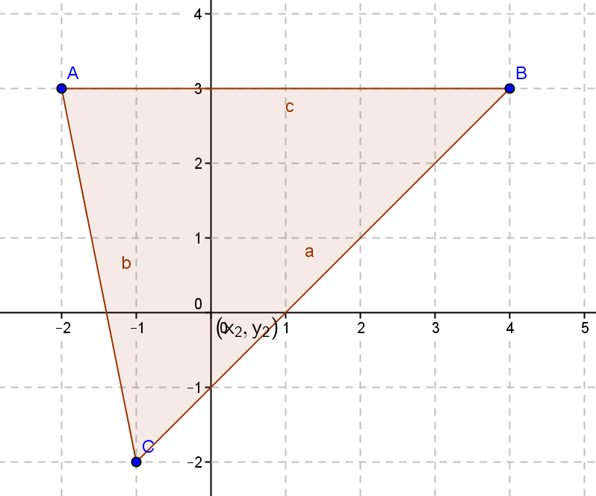

Calculate the perimeter and area of the triangle:

Perimeter =

Area =

Name ___________________________________________________ Period _______ Date_______________

8.13: Perimeter and Area of Triangles in the Cartesian Plane Exit Ticket

1. Given the triangle below with vertices $A (-2, 3)$, $B (4, 4)$, and $C (-1, -2).$



Calculate the perimeter and area of the triangle:

Perimeter =

Area =